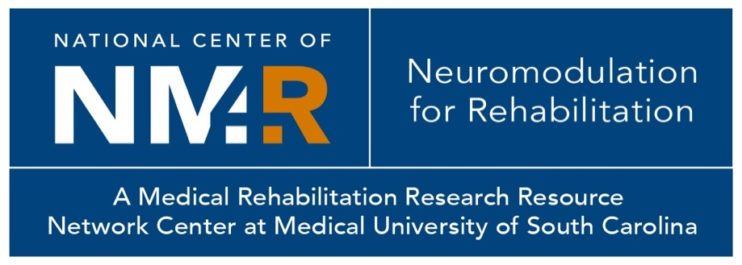
National Center of Neuromodulation for Rehabilitation
77 President Street
Room C319 MSC 700
Charleston, SC 29425-7000
Tel 843 792 1364
Email: ncnm4r@musc.edu
Website: www.musc.edu/ncnm4r/
Fax 843 792 1358

Letter of Intent
Pilot Project Program 2024-2025 Cycle
National Center of Neuromodulation for Rehabilitation

Complete sections 1 through 10, using Arial 11-point font, single-spaced. A bibliography is not required but may be included within the three-page limit. Do not alter margins, delete form text, or exceed the three-page form limit. Section 11 is to be completed only for resubmissions of a full grant application.
1 | PI/Applicant Name  (first, last, degree(s))
2 | Institution/Organization & Academic Rank
3 | PI/Applicant Email Address & Telephone
4 | Mentor/Co-Investigators (name, institution, academic rank, email address)
5 | Project Title
6 | Hypotheses and Objective of the Project (500 words)
7 | Overview of the Study Design/Methods (500 words)
8 | Relevance to the Scientific Field of Neuromodulation for Rehabilitation Research (100 words)
9 | Is the work proposed utilizing a new technique, technology, or area of work for the PI? If so, please provide a brief statement on the inclusion of mentors, collaborators, and/or consultants the PI will work with for successful completion of the proposed studies. (max 200 words)
10 | Is this a resubmission of a previously reviewed (but not funded) NM4R Pilot Project Program application? |  |  | Yes |  | No
11 | Resubmission (500 words): If this LOI is a first resubmission of a previously reviewed but not funded full grant application, up to a half-page may be appended to the end of this LOI template to respond to reviewer comments; this half-page does not count in the three-page limit.

Submission Instructions:

Click this link to submit your LOI: https://redcap.musc.edu/surveys/?s=LRLJPH8X4ERXT9ND

